**Running the POC IVD Demo**

The POC IVD demo simply demos the data collection workflow for a lateral flow diagnostics POC device.

(What is lateral Flow Diagnostics? Think of the little COVID test cartridges where a red line shows up to tell you if you have COVID-19 or not). There are 3 JADAK devices in the demo:

* An M3e for authentication of an operator ID
  + The M3e does not have an LF antenna hooked up so it will not read LF cards, only HF cards
* A VIBE for reading the patient ID barcode on the bottom of the test cartridge
* An Allegro IVD 5MP for imaging of the top of the test cartridge and determining the test results. The test results are determined by a pyClarity graph running on the Allegro IVD camera.
  + Please note that 5MP is overkill for this application, but it shows the concept.
* There is also a REACH display in the front of the demo unit.
  + That display acts as a controller for the M3e, VIBE, and Allegro IVD. The Read button is bound to the M3e, and the Analyze button to the VIBE and Allegro IVD.

**Set up instructions:**

1. Ensure all devices are tightly secured. The M3e, Vibe, and Penny Whistle should all be connected to the USB hub. The USB hub should be connected to the G3 and connected the USB female on the wall of the demo’s box be powered.
2. Connect the two USB cables used to power the hub and light source to the USB ports visible on the back of the demo.
3. After all the devices have powered up, connect the G3’s 5-volt power supply to its respective port on the back of the demo.

- Note the display can take a minute or so to begin the application after powering up.

1. Ensure the light source is positioned correctly. This can be tested by inserting a test cartridge and confirming that the lines on the test are being illuminated.

**How to run the demo:**

1. Click on the “read” button to initialize the M3e and to begin searching for an HF RFID tag.

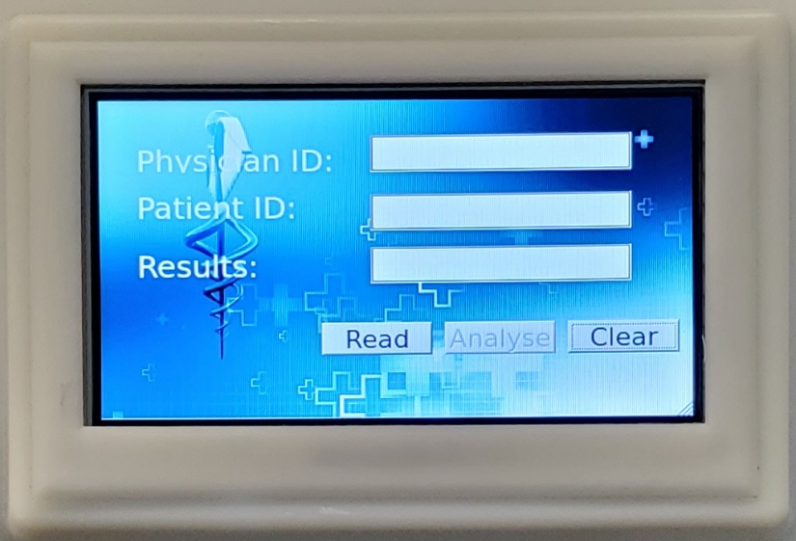

1. Present a valid RIFD card to the front area of the POC demo, where the RFID symbol is located  
   - if a valid RFID ID is presented the analyze button will become available, and the operator’s name on the ID card will appear under “Physician ID”. We have provided 2 valid ID cards with the demo.  
   if an invalid ID card is presented, you cannot analyze a test strip (the analyze button will remain grayed out).

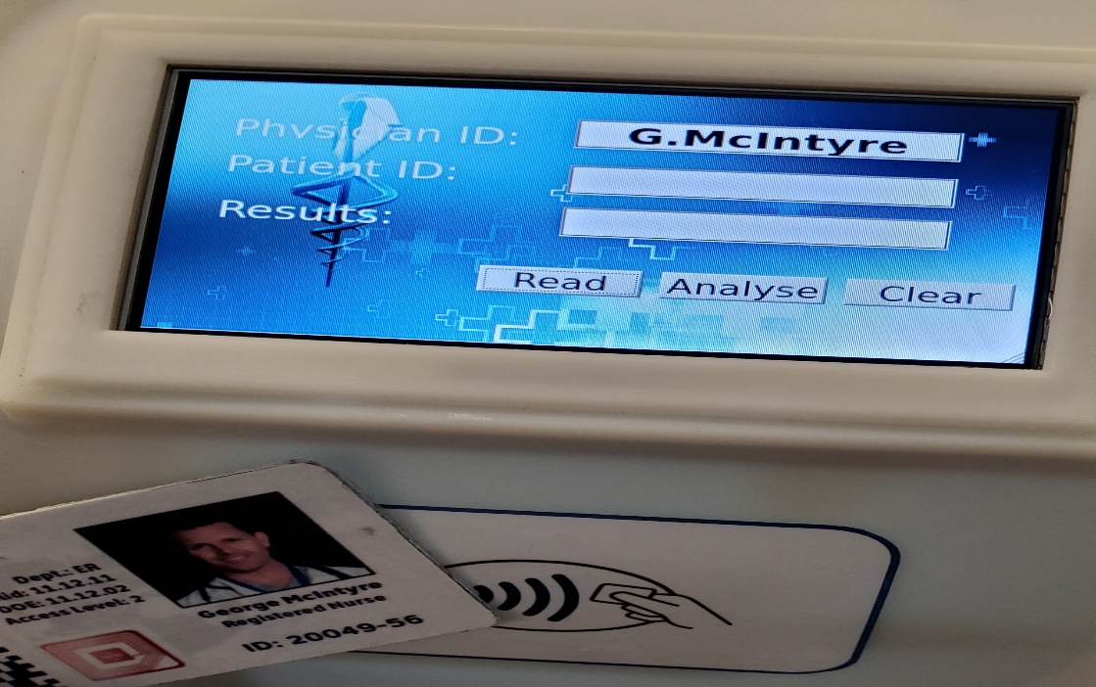

1. Insert one of the test cartridges. Three cartridges have been provided – one is “positive”, one is “negative”, and one is “invalid”. Note that there is a “key’ right on the test strips that outlines the conditions for each of those results.  
   - click on the “Analyze” button   
   - after you click on “Analyze” the VIBE will read the patient ID from the bottom of the cartridge and output the patient name that is associated with that ID  
   - The Pennywhistle will capture an image of the top of the cartridge and output the test results

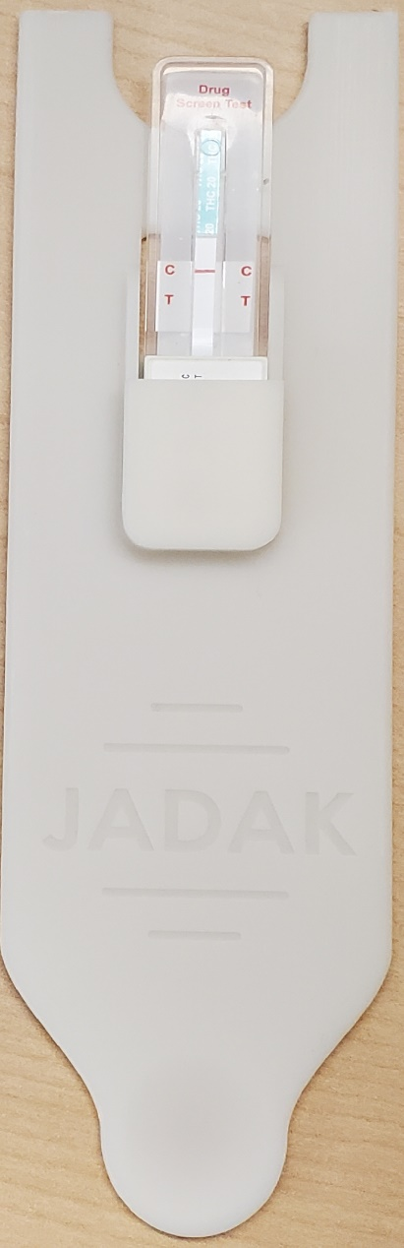 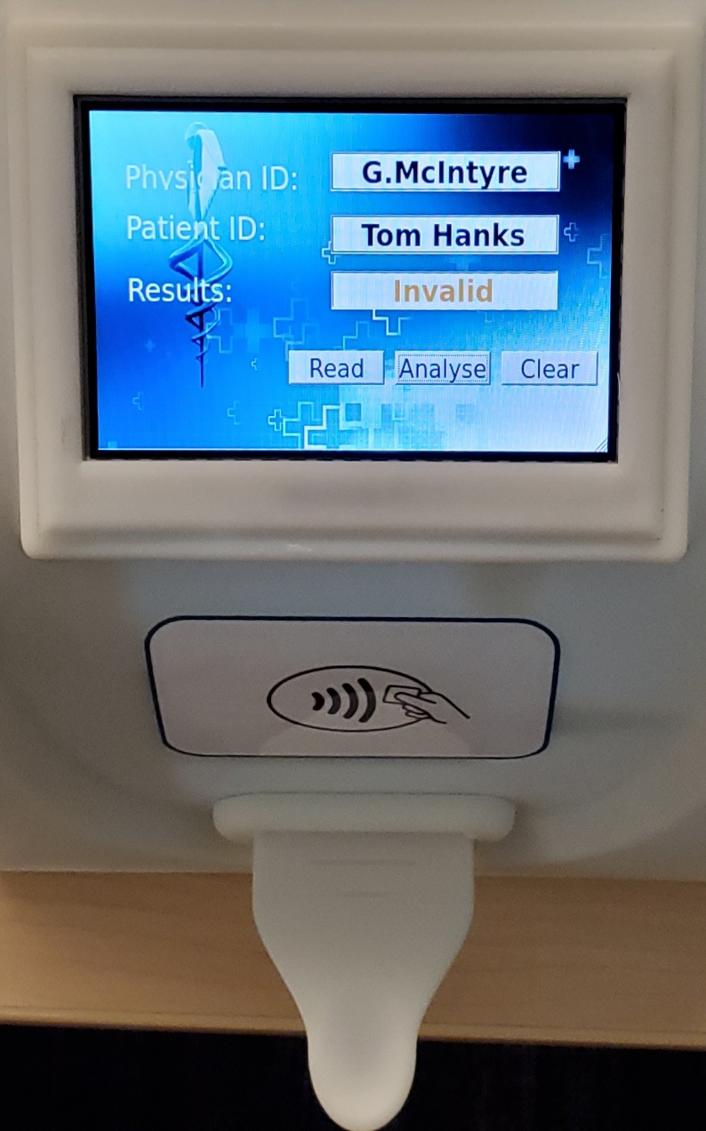

Inserting the Cartridge Screen with complete results

Misc notes:

* There are 2 connections needed:
  + A power-only USB port for a hub that connects to the VIBE, Pennywhistle, and the M3e to the display
  + A power-only USB port for internal lighting used for the machine vision